Experiment 1: Magnitude of money is manipulated

Participant is presented with a choice between 1) tone at a predetermined duration of time (e.g., 10s) and an adjusting-amount money magnitude (e.g., $0.50) or 2) silence at an equal duration to the tone and a set money magnitude (sample choices included below). The participant makes six choices for each money magnitude with the first choice being an equal amount of time of silence at no money and the tone for each money magnitude. If the participant selects the silence option, the amount of money for the tone increases by 50% of the value for the subsequent trial. If the participant selects the tone option, the tone option will decrease by 50%. Each subsequent choice will alter the change in value of the money by 50% of the previous adjustment up to $1.00 or a minimum of $0.00. This is repeated for each duration delay (i.e., 10, 15, 30, 45 s).

Sample Data: 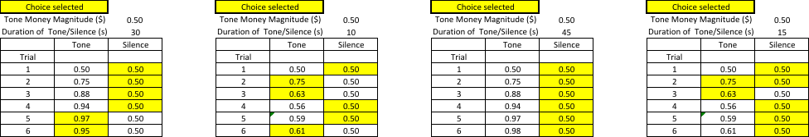Graphic representation: 

Experiment 2: Duration of tone is manipulated

Participant is presented with a choice between 1) tone at an adjusting-amount duration and a predetermined money magnitude (e.g., $0.25) or 2) silence at a predetermined duration (e.g., 10, 15, 30, and 45 s) and no money. The participant makes six choices for each money magnitude with the first choice being an equal amount of time of silence at no money and the tone for each money magnitude. If the participant selects the silence option, the amount of time for the tone decreases by 50% of the duration for the subsequent trial. If the participant selects the tone option, the tone option will increase by 50%. Each subsequent choice will alter the change in duration of the tone by 50% of the previous adjustment up to 90 s or a minimum of 0 s. This is repeated for each money magnitude (i.e., $0.25, $0.50, $0.75, and $1.00).

Sample Data: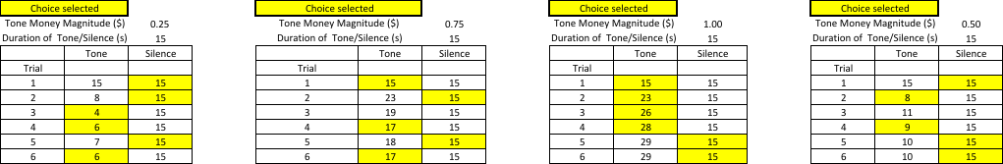

Graphic representation: 

Experiment 3: Duration of silence is manipulated

Participant is presented with a choice between 1) a tone at a predetermined duration amount of time (e.g., 15 s) and set money magnitude (e.g., $0.25) or 2) silence at an adjusting duration for no money. The participant makes 6 choices for each money magnitude with the first choice being an equal duration of the tone for each money magnitude or silence with no money. If the participant selects the silence option, the amount of time for the silence increases by 50% of the duration for the subsequent trial. If the participant selects the tone option, the silence option will decrease by 50%. Each subsequent choice will alter the change in duration of silence by 50% of the previous adjustment up to 90 s or a minimum of 0 s. This is repeated for each money magnitude (i.e., $0.25, $0.50, $0.75, and $1.00).

Sample Data:

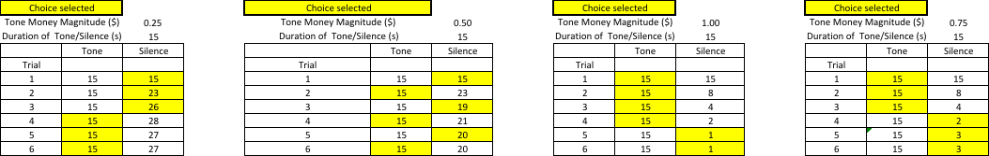Graphic Representation: 